CAMPUS CAFÉ ORDERING SYSTEM

JAVA OBJECT-ORIENTED PROGRAMMING LABORATORY EXERCCISE

Prepared by:
ELLOSO,EDLYN JOY
LINDAYAO,ESSA
CADIVIDA,PRINCES RHEAMAE

Course/Section
BSINT - 2 ITS202 -OBJECT - ORIENTED PROGRAMMING/SECTION-D

Date:November 9, 2026
Negros Oriental State University - Campus 1

‘

OPP Concepts and Their Application
Encapsulation -Encapsulation is used by declaring most variables as private or protected. Getters and setters are provided to access and update the information safely.
Inheritance -The Beverage, Pastry, and Meal classes inherit from the MenuItem class. This allows them to reuse the common properties and methods of menu items.
Abstraction -The MenuItem class is declared as an abstract class. It contains the abstract method computePrice(), which must be implemented by its child classes.
Polymorphism -Polymorphism is demonstrated through method overriding and method overloading. Different menu items have their own price computations, while some methods can accept different parameters.
Constructor Overloading -The Customer class has three constructors: a default constructor, a constructor with a name, and a constructor with a name and student status. This allows customers to be created in different ways.
Method Overloading -The addPoints() method accepts either an integer or a double value. The computeTotal() method can also calculate the total with or without a voucher.
Method Overriding -The Beverage, Pastry, and Meal classes override the computePrice() and getDescription() methods to provide their own behavior.
Conditional Statements - If and if-else statements are used to check beverage sizes, calculate additional charges, validate prices, apply discounts, and limit the number of items in an order.

Actual Program Output
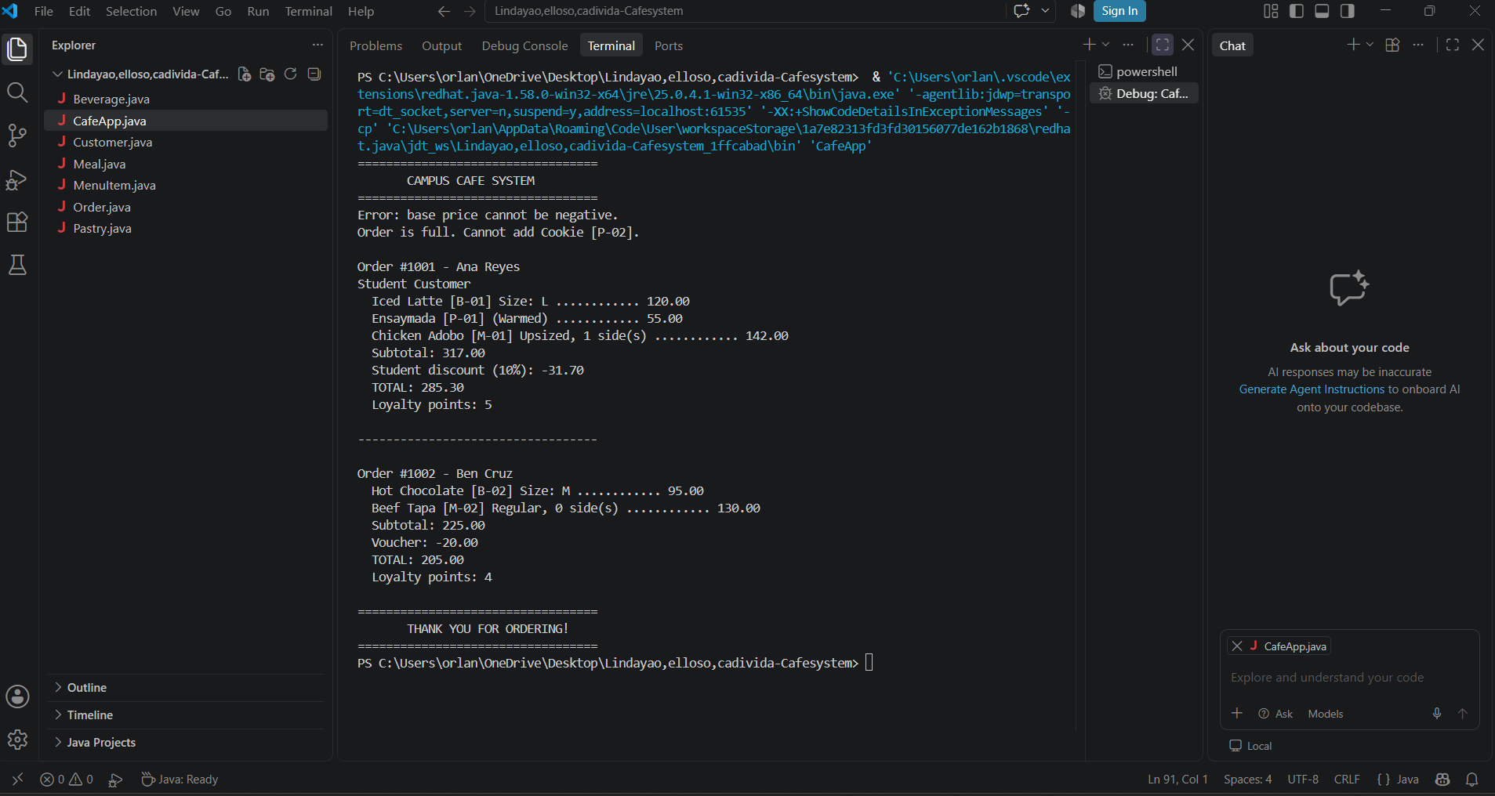
- Challenges Encountered and Solutions
During the development of the Campus Café Ordering System, we encountered some challenges in understanding and applying the different Java OOP concepts.
One challenge was understanding how inheritance works. At first, it was difficult to determine how the child classes could reuse the properties and methods of the parent class. We addressed this by creating MenuItem as the parent class and extending it through Beverage, Pastry, and Meal.
Another challenge was implementing method overriding and method overloading. We solved this by giving the menu item classes their own computePrice() methods and creating methods with different parameter lists in Customer and Order.
We also encountered challenges in calculating the correct prices, discounts, and loyalty points. To solve these problems, we used conditional statements and tested the program using different menu items and customer orders.
Lastly, we needed to make sure that invalid values were not accepted. We used validation inside setters to prevent negative prices, negative extra sides, and invalid beverage sizes.
Through testing and correcting the code, we were able to make the system work according to the given requirements.

- Conclusion
The Campus Café Ordering System helped us understand the importance of Object-Oriented Programming in Java. Through this activity, we learned how to create and use classes and objects, apply inheritance and abstraction, protect data using encapsulation, and demonstrate polymorphism through method overloading and overriding.
We also learned how constructors, conditional statements, and validation methods help make a program more organized and reliable.
Overall, this laboratory exercise improved our understanding of Java programming and helped us gain practical experience in developing a simple ordering system. It also taught us how different classes can work together to complete a particular task

